**GROUP PROJECT, GROUP 3**

**DATE: 05th December 2018**

**TIME: 12:00 – 16:00**

**ATTENDEES** Henry Crofts, Tom Gibbs

**LOCATION:** Common Room, Atrium

**Minute Taker: Henry Crofts**

**Overall aims of the current sprint *(Detailed tasks, user stories and time allocations are tracked on JIRA)***

* Review completed tasks from previous sprint
* Identify subsequent tasks for this sprint, negotiate allocation of tasks
* Confirm team availability this sprint to ensure 2 full-day studio-jams
* Work towards setting up the pitch presentation ready for Monday 10th December

**Meeting:**

Both Present

The team met up to complete some of the tasks for the current sprint. Tom made a start on his player ID tasks to put a circle around the player, however he ran into a lot of difficulty with this task asking Chris and Steve for help, Henry made a start on the presentation sorting out videos and screenshots to show how the game would look at X number of minutes and planning the layout of the presentation.

***Detailed tasks, task descriptions, user stories and time allocations are tracked on JIRA.***

**Tasks for the current week:**

**Tom (11 Hours 30mins):**

* **Rehearse presentation (2h)**

Once the presentation has been fully adjusted with the new content, spend time in A2.07 (or another free room) and rehearse individual parts of the presentation with Henry.

* **Adjust presentation with Henry (3h)**

Spend time going through the presentation, working out which slides need updating with the latest build of the game and which slides will need to be completely changed. Make these adjustments with Henry in a studio-jam style.

* **Model Fire Pit (2h)**

Model a fire pit to go at the end of the boat for the torch to spawn in. Design will be discussed on Tuesday 4th December.

* **Crow’s Nest UI (1h 30m)**

Animate a textbox that scrolls out as we have mentioned in previous meetings and create the textbox / sprites that will be used as “content” for the UI speech bubble.

* **Player ID (3h)**

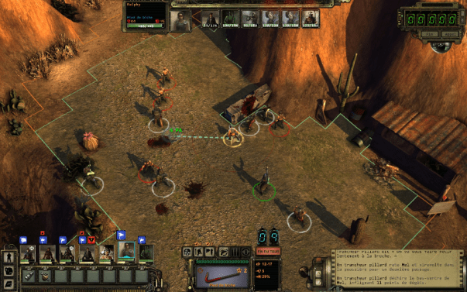Explore different techniques that can be used to show the player ID as a ring around the players feet, so each player will know who they are controlling, reference pictures such as where each player has a ring around them, investigate using *Shaders* and *Projectors*.

**Henry (12 Hours 30 mins):**

* **Rehearse presentation (2h)**

Once the presentation has been fully adjusted with the new content, spend time in A2.07 (or another free room) and rehearse individual parts of the presentation with Tom.

* **Adjust presentation with Tom (3h)**

Spend time going through the presentation, working out which slides need updating with the latest build of the game and which slides will need to be completely changed. Make these adjustments with Henry in a studio-jam style.

* **Cannon status UI (1h 30m)**

Implement the UI for the cannon to show the player when the Gunpowder and/or Cannonball is loaded, once both items are loaded in, swap the sprites out to show a torch.

* **Update the enemy flag to work for the presentation (2h)**

Fix and update the enemy flag to show the correct position of the enemies in preparation for the presentation.

* **Update the enemy cannons to work for the presentation (2h)**

Fix the cannon hit placement to show the correct location where the cannonball is going to land on the player’s boat.

* **Complete repair deck script (2h)**

Complete the script that allows the player to pick up a plank of wood and take it to a damaged section of the ship and repair it.